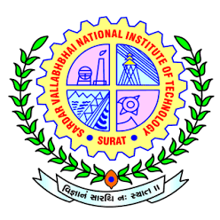 | S.V. NATIONAL INSTITUTE OF TECHNOLOGY SURAT-395007.  Proposed Examiners for Ph.D. Thesis Review

Name of Student
Registration No
Name of the Department
Title of the Thesis
Name of Supervisor(s)
Date of Registration
Date of Pre-synopsis seminar
Date of synopsis Submission

Examiners from Abroad
Sr. No. | Name, Designation, Affiliation, Address, Email ID and Webpage Details | Area of Specialization
Name:
Designation:
Affiliation:
Postal Address:
Email ID:
Web Link:

Name:
Designation:
Affiliation:
Postal Address:
Email ID:
Web Link:

Name:
Designation:
Affiliation:
Postal Address:
Email ID:
Web Link:

Name:
Designation:
Affiliation:
Postal Address:
Email ID:
Web Link:

Name:
Designation:
Affiliation:
Postal Address:
Email ID:
Web Link:

Examiners from India
Sr. No. | Name, Designation, Affiliation, Address, Email ID and Webpage Details | Area of Specialization
Name:
Designation:
Affiliation:
Postal Address:
Email ID:
Web Link:

Name:
Designation:
Affiliation:
Postal Address:
Email ID:
Web Link:

Name:
Designation:
Affiliation:
Postal Address:
Email ID:
Web Link:

Name:
Designation:
Affiliation:
Postal Address:
Email ID:
Web Link:

Name:
Designation:
Affiliation:
Postal Address:
Email ID:
Web Link:

Name and Signatures of Pre-Synopsis Committee Members:

Name and Signature of Supervisor | Head of Department | Dean (Academic) | Director

